**Project Design Phase-II**

**Data Flow Diagram & User Stories**

|  |  |
| --- | --- |
| Date | 30-06-2025 |
| Team ID |  |
| Project Name | Social media mern app |
| Maximum Marks | 4 Marks |

**🔁 Data Flow Diagram (DFD):**

The Data Flow Diagram for **SocialeX** represents the movement of data between users (content creators and viewers), the backend system, and the database. It outlines how interactions such as sign-up, posting, liking, commenting, and exploring content are processed within the system.

**Level 1 DFD Summary:**

* **Users:**
  + Register/Login
  + Post content
  + Like & comment on others' posts
  + Follow/unfollow users
  + Receive notifications
* **Processes:**
  + User Authentication
  + Feed Management
  + Interaction Handling (likes, comments)
  + Notification Service
  + Profile & Password Management
* **Data Stores:**
  + User Database
  + Post & Interaction Logs
  + Follower/Following Graph
  + Notification Logs
* 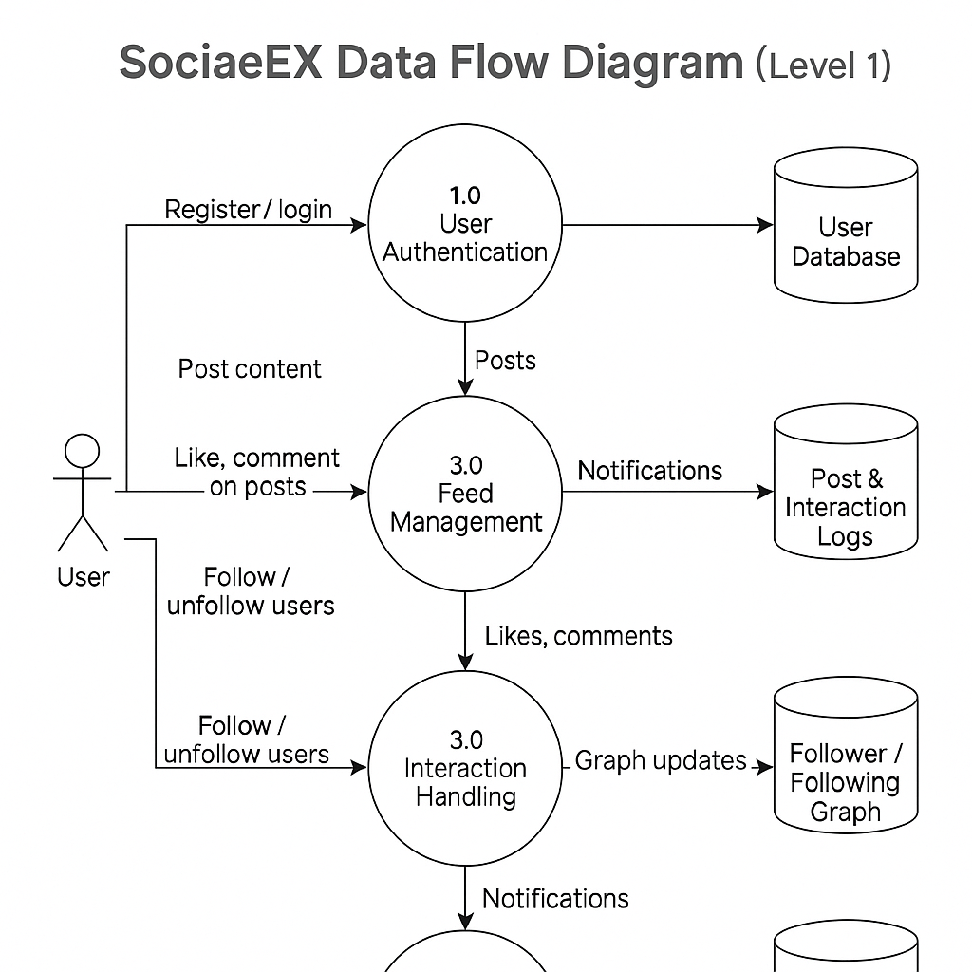

**📚 User Stories**

|  |  |  |  |  |  |
| --- | --- | --- | --- | --- | --- |
| **User Type** | **Functional Requirement (Epic)** | **User Story / Task** | **Acceptance Criteria** | **Priority** | **Release** |
| User | User Registration | As a user, I can register and log in securely. | Redirected to dashboard after successful login. | High | Sprint-1 |
| User | Feed System | As a user, I can see a global feed of posts. | Posts load with most recent content. | High | Sprint-1 |
| User | Post Creation | As a user, I can create and delete posts. | Post appears instantly in feed and my profile. | High | Sprint-2 |
| User | Post Interaction | As a user, I can like and comment on posts. | Interactions are visible in real-time. | Medium | Sprint-2 |
| User | Profile Management | As a user, I can update my profile and picture. | Changes are saved and reflected on my profile. | Medium | Sprint-3 |
| User | Follow System | As a user, I can follow or unfollow other users. | Updated follower/following count immediately. | High | Sprint-3 |
| User | Explore Feed | As a user, I can explore popular posts by tags. | Returns relevant posts for selected filters. | Medium | Sprint-4 |
| User | Notifications | As a user, I receive notifications on likes and follows. | Notification badge updates in real time. | Medium | Sprint-4 |
| User | Password Security | As a user, I can change/reset my password securely. | Password updated and confirmation sent. | Medium | Sprint-4 |
| Admin | User Moderation | As an admin, I can manage flagged users or content. | Actions are logged in moderation history. | High | Sprint-4 |